5.

create database project_movie_data;

use project_movie_data;

create table actor(

act_id int primary key auto_increment,

act_fname varchar(45),

act_lname varchar(45),

act_gender enum('M','F')

)auto_increment=101;

select*from actor;

create table director(

dir_id int primary key auto_increment,

dir_fname varchar(45),

dir_lname varchar(45)

)auto_increment=201;

select * from director;

create table movie(

mov_id int primary key auto_increment,

mov_title varchar(50),

mov_year int not null,

mov_time int not null,

mov_lang varchar(50) not null,

mov_dt_rel date,

mov_rel_country varchar(10)

)auto_increment=901;

select * from movie;

create table movie_direction(

dir_id int not null,

mov_id int not null,

foreign key(dir_id) references director(dir_id),

foreign key(mov_id) references movie(mov_id)

);

select * from movie_direction;

create table movie_cast(

act_id int not null,

mov_id int not null,

role varchar(30),

foreign key(act_id) references actor(act_id),

foreign key(mov_id) references movie(mov_id)

);

select * from movie_cast;

create table reviewer(

rev_id int primary key auto_increment,

rev_name varchar(30)

)auto_increment=9001;

select * from reviewer;

create table genres(

gen_id int primary key auto_increment,

gen_title varchar(20)

)auto_increment=1001;

select * from genres;

create table movie_generes(

mov_id int not null,

gen_id int not null,

foreign key(mov_id) references movie(mov_id),

foreign key(gen_id) references genres(gen_id)

);

select * from movie_generes;

create table rating(

mov_id int not null,

rev_id int not null,

rev_stars int,

num_o_ratings int,

foreign key(mov_id) references movie(mov_id),

foreign key(rev_id) references reviewer(rev_id) );

select * from rating;

show tables;

INSERT INTO director(dir_fname,dir_lname)

values('Alfred','Hitchcock'),('Jack','Clayton'),('David','Lean'),

('Michael','Cimino'),('Milos','Forman'),('Ridley','Scott'),

('Stanley','Kubrick'),('Bryan','Singer'),('Roman','olanski'),

('Paul','Thomas Anderson'),('Woody','Allen'),('Hayao','Miyazaki'),

('Frank','Darabont'),('Sam','Mendes'),('James','Cameron'),

('Gus',' Van Sant'),('John',' Boorman'),('Danny','Boyle'),

('Christopher','Nolan'),('Richard','Kelly'),('Kevin','Spacey'),

('Andrei','Tarkovsky'),('Peter','Jackson');

select * from director;

insert into movie(mov_title,mov_year,mov_time,mov_lang,mov_dt_rel,mov_rel_country)

values('Vertigo',1958,128,'English','1958-08-24','UK'),('The Innocents',1961,100,'English','1962-02-19','SW'),

('Lawrence of Arabia',1962,216,'English','1962-12-11','UK'),('The Deer Hunter',1978,183,'English','1979-03-08','UK'),

('Amadeus',1984,160,'English','1985-01-07','UK'),('Blade Runner',1982,117,'English','1982-09-09','UK'),

('Eyes Wide Shut',1999,159,'English',null,'UK'),('The Usual Suspects',1995,106,'English','1995-08-09','UK'),

('Chinatown',1974,130,'English','1974-08-09','UK'),('Boogie Nights',1997,155,'English','1998-02-16','UK'),('Annie Hall',1977,93,'English','1977-04-20','USA'),

('Princess Mononoke',1997,134,'Japanese','2001-10-19','UK'),('The Shawshank Redemption','1994','142','English',' 1995-02-17','UK'),('American Beauty',1999,122,'English',null,'UK'),

('Titanic',1997,194,'English','1998-01-23','UK'),('Good Will Hunting',1997,126,'English','1998-06-03','UK'),('Deliverance',1972,109,'English','1982-10-05','UK'),

('Trainspotting',1996,94,'English','1996-02-23','UK'),('The Prestige',2006,130,'English','2006-11-10','UK'),('Donnie Darko',2001,113,'English',null,'UK'),

('Slumdog Millionaire',2008,120,'English','2009-01-09','UK'),('Aliens',1986,137,'English','1986-08-29','UK'),('Beyond the Sea',2004,118,'English','2004-11-26','UK'),

('Avatar',2009,162,'English','2009-12-17','UK'),('Seven Samurai',1954,207,'Japanese','1954-04-26','JP'),('Spirited Away',2001,125,'Japanese','2003-09-12','UK'),

('Back to the Future',1985,116,'English','1985-12-04','UK'),('Braveheart',1995,178,'English','1995-09-08','UK');

insert into movie_direction(dir_id,mov_id)

values(201,901),(202,902),(203,903),

(204,904),(205,905),(206,906),

(207,907),(208,908),(209,909),

(210,910),(211,911),(212,912),

(213,913),(214,914),(215,915),

(216,916),(217,917),(218,918),

(219,919),(220,920),(218,921),

(215,922),(221,923);

insert into genres(gen_title)

values('Action'),('Adventure'),('Animation'),('Biography'),

('Comedy'),('Crime'),('Drama'),('Horror'),

('Music'),('Mystery'),('Romance'),('Thriller'),

('War');

insert into actor(act_fname,act_lname,act_gender)

values('James','Stewart','M'),('Deborah','Kerr','F'),('Peter','Otoole','M'),('Robert','DeNiro','M'),

('F.Murray','Abraham','M'),('Harrison','Ford','M'),('Nicole','Kidman','F'),('Stephen','Baldwin','M'),

('Jack','Nicholson','M'),('Mark','Wahlberg','M'),('Woody','Allen','M'),('Claire','Danes','F'),

('Tim','Robbins','M'),('jon','Voight','M'),('Kevin','Spacey','M'),('Kate','Winslet','F'),('Robin','Robbins','M'),

('Ewan','McGregor','M'),('Christian','Bale','M'),('Maggie','Gyllenhaal','F'),('Dev','Patel','M'),('Sigourney','Weaver','F'),

('David','Aston','M'),('Ali','Astin','F');

insert into movie_cast(act_id,mov_id,role)

values(101,901,'John Scottie Ferguson'),(102,902,'Miss Giddens'),(103,903,'T.F.Lawrence'),(104,904,'Michael'),

(105,905,'Antonia Salieri'),(106,906,'Rick Deckard'),(107,907,'Alice Harford'),(108,908,'McManus'),

(110,910,'Eddie Adams'),(111,911,'Alvy Singer'),(112,912,'San'),(113,913,'Andy Dulresne'),(114,914,'Lester Burnham'),

(115,915,'Rose DeWitt Bukater'),(116,916,'Sean Maguire'),(117,917,'Ed'),(118,918,'Renton'),(120,920,'Elizabeth Darko'),

(121,921,'Older Jamal'),(122,922,'Ripley'),(114,923,'Bobby Darin'),(109,909,'J.J.Gittes'),(119,919,'Alfred Borden');

insert into reviewer(rev_name)

values('Righty sock'),('Jack Malven'),('Flagrant Malvern'),('Alec Shaw'),

(null),('Victor Woeltjen'),('Simon Wright'),('Neal Wruck'),

('Paul Monks'),('Mike Salvati'),(null),('Weasly S.Walker'),

('Sasha Goldshtein'),('Josh Cates'),('Krug Stillo'),('Scott LeBrun'),

('Hannah Steele'),('Vincent Cadena'),('Brandt Sponseller'),('Richard Adams');

insert into movie_generes(mov_id,gen_id)

values(922,1001),(917,1002),(903,1002),(912,1003),(911,1005),(908,1006),(913,1006),(926,1007),(928,1007),(918,1007),

(921,1007),(902,1008),(923,1009),(907,1010),(927,1010),(901,1010),(914,1011),(906,1012),(904,1013);

insert into rating(mov_id,rev_id,rev_stars,num_o_ratings)

values(901,9001,8.4,263575),(902,9002,7.9,20207),(903,9003,8.3,202778),(906,9005,8.2,484746),

(924,9006,7.3,null),(908,9007,8.6,779489),(909,9008,null,227235),(910,9009,3,195961),

(911,9010,8.1,203875),(912,9011,8.4,null),(914,9013,7,862618),(915,9001,7.7,830095),

(916,9014,4,642132),(925,9015,7.7,81328),(918,9016,null,580301),(920,9017,8.1,609451),

(921,9018,8,667758),(922,9019,8.4,511613),(923,9020,6.7,13091);

select mov_title,gen_title from movie

inner join movie_generes on movie.mov_id=movie_generes.mov_id

inner join genres on genres.gen_id=movie_generes.gen_id

where genres.gen_title='Horror';

select rev_name,rev_stars from reviewer

inner join rating on reviewer.rev_id=rating.rev_id

where rev_stars>=8;

select act_fname,act_lname,act_gender,mov_title from actor

inner join movie_cast on actor.act_id=movie_cast.act_id

inner join movie on movie_cast.mov_id=movie.mov_id

where movie.mov_title='Deliverance';

select mov_title,rev_stars,mov_year from movie

inner join rating on movie.mov_id=rating.mov_id

where rev_stars>=4;

select mov_title,dir_fname,dir_lname from movie

inner join movie_direction on movie.mov_id=movie_direction.mov_id

inner join director on movie_direction.dir_id=director.dir_id

where director.dir_fname='David' or director.dir_lname='David';

select act_fname,act_lname,mov_title,role from actor

inner join movie_cast on actor.act_id=movie_cast.act_id

inner join movie on movie_cast.mov_id=movie.mov_id

where movie.mov_title='Boogie Nights';

1. OUTPUT

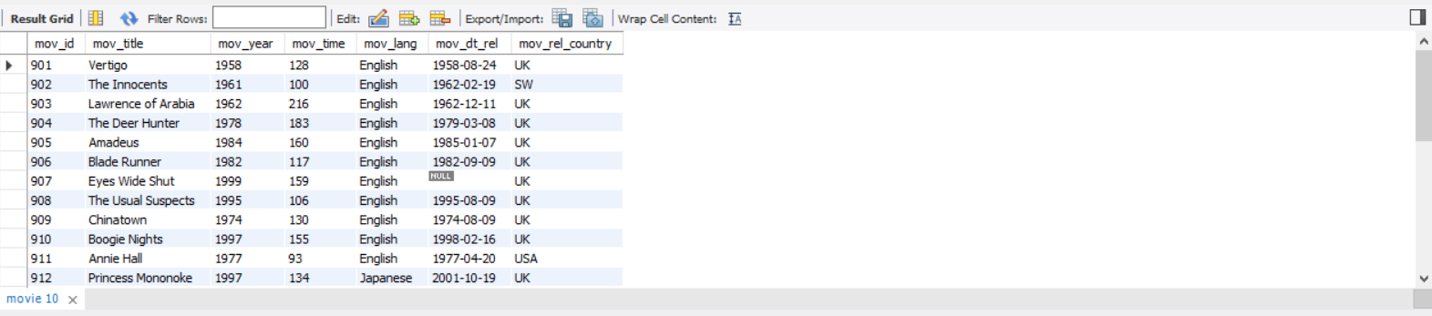

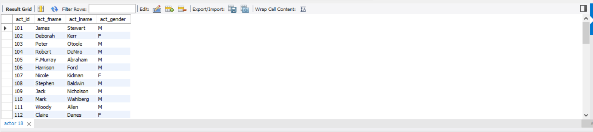

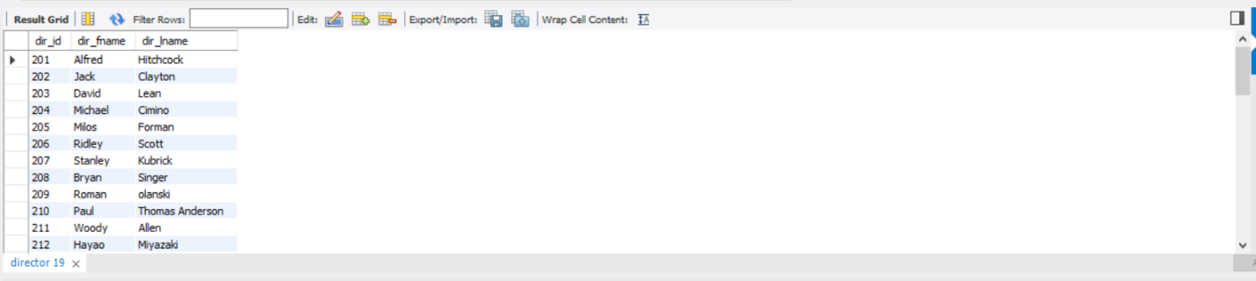

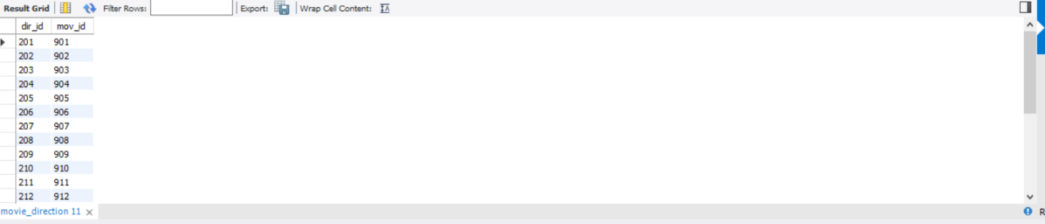

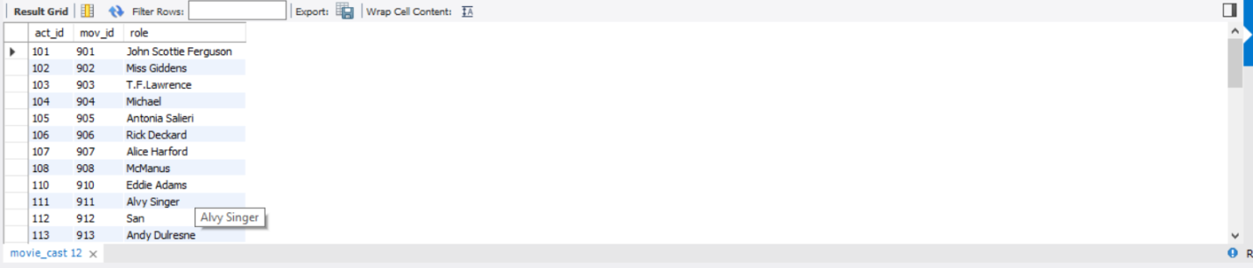

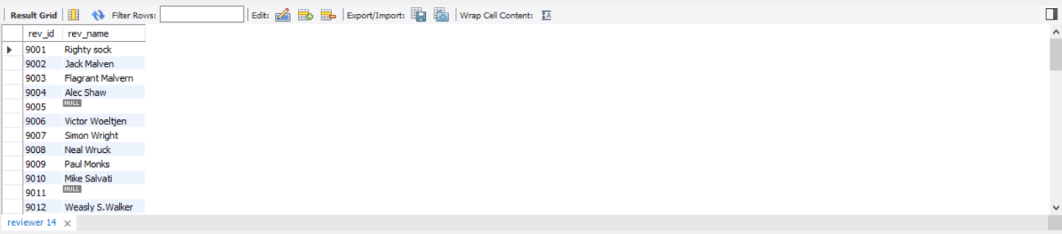

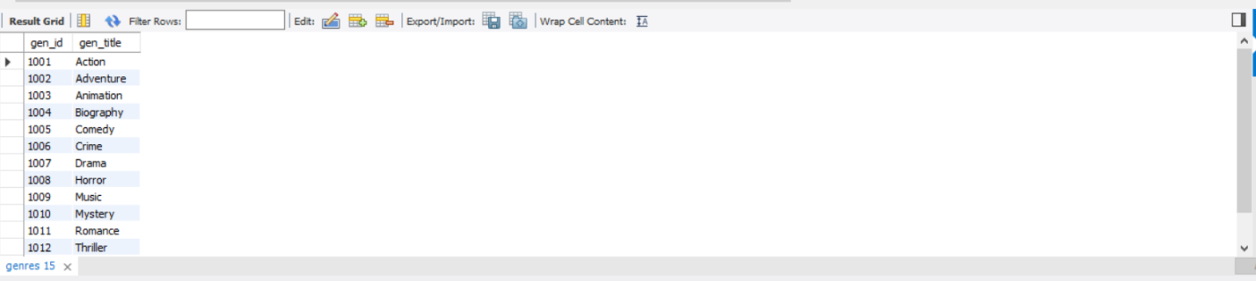

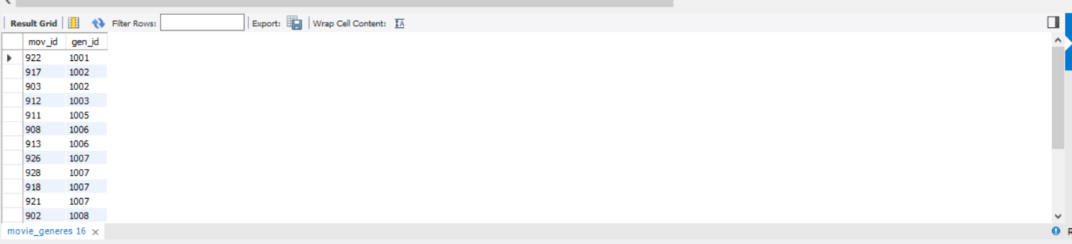

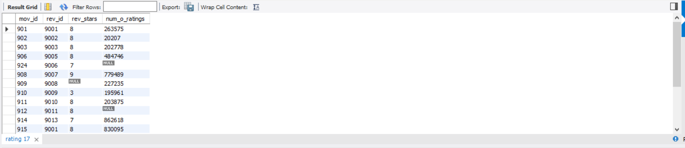

2.

3.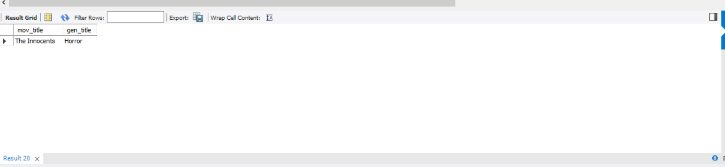

4. 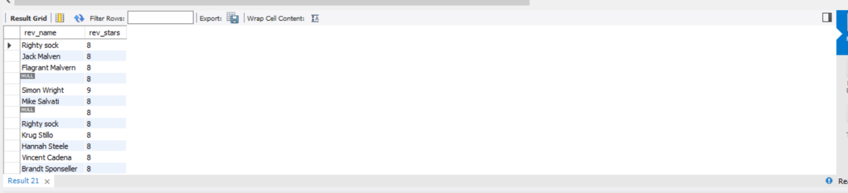5.

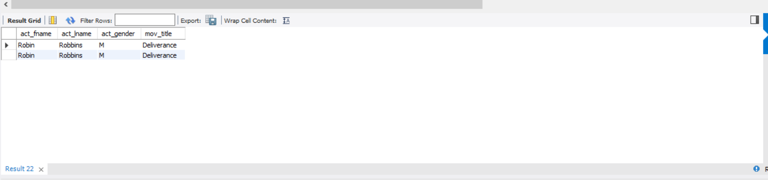

6.

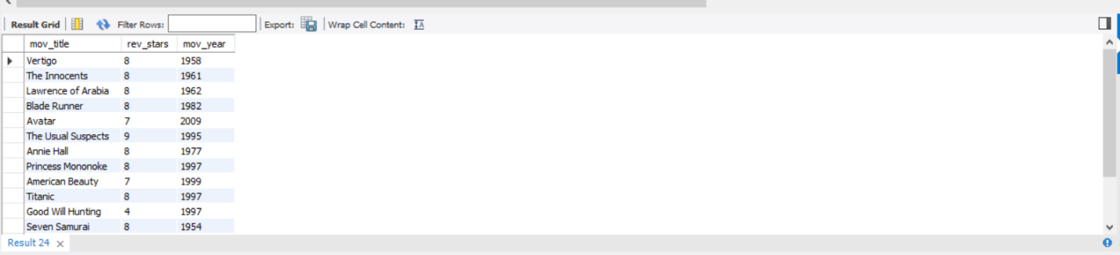

7.

8.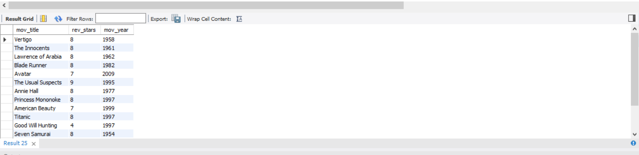

9.

10.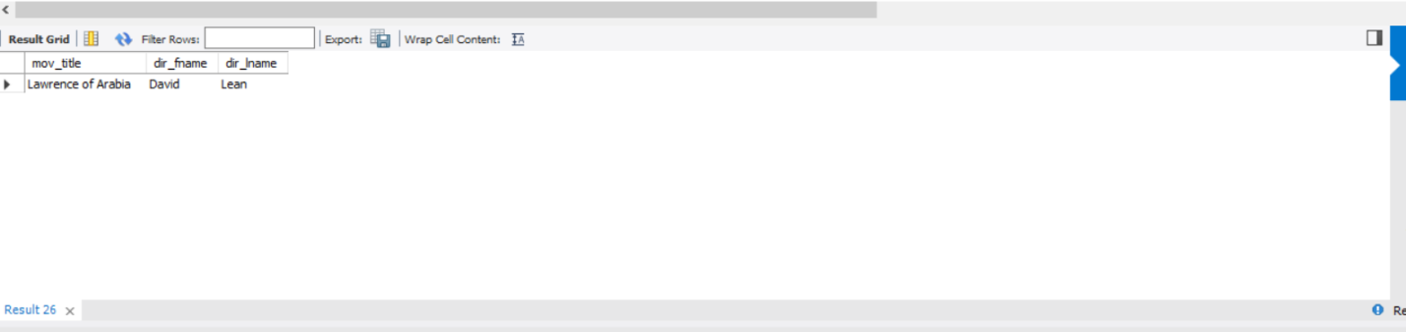

11.